ASSIGNMENT # 4-1 Due on 16/12/19 Student # …………… Name ………………………….

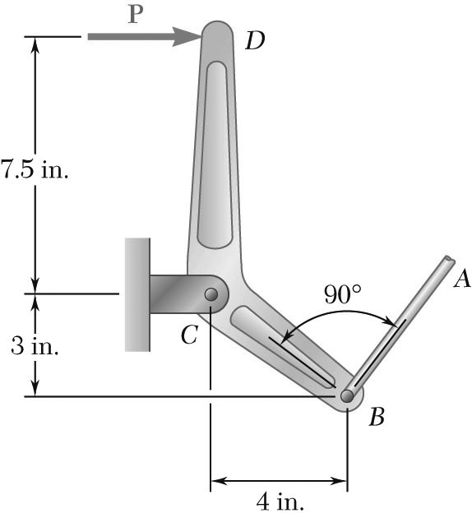

The lever *BCD* is hinged at *C* and attached to a control rod at *B*.

If *P* = 100 lb, determine

(*a*) the tension in rod *AB*,

(*b*) the reaction at *C*

**STATICS** ***UDM ENGR 3120*** - ***BUCT MEC 1701-1703*** ***CHAPTER 4 – Equilibrium of Rigid*** ***Bodies*** Student Name……………….........